User
manual

8020Fit.AI

Team FitForce
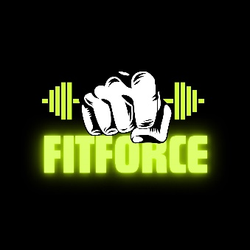
May 2025




Table of Contents
Introduction ............................................................................ 4
Getting Started ....................................................................... 5
- Creating Your Account ................................................ 5
- Login Into Your Account .............................................. 6
Navigation .............................................................................. 8
- Dashboard ................................................................... 8
Profile ....................................................................................12
- View Profile ............................................................... 12
- Update Profile............................................................ 13
- Delete Account Profile ............................................... 13
- Logout of Account ..................................................... 14
Workout Generation ............................................................. 15
- Take Onboarding Quiz .............................................. 15
- View and Track Workouts.......................................... 18

Meal Plan ............................................................................. 21
- Enter Meal Preferences ............................................ 21
- View Meal Plan ......................................................... 22
AI Chatbot ............................................................................ 23
- AI Chat Prompts ........................................................ 23
Admin ................................................................................... 25
- View Admin Features ................................................ 25
Contact Information .............................................................. 26

Introduction
Welcome to the 8020Fit Installation Manual. 8020Fit.AI is a comprehensive fitness platform deigned to optimize nutrition, fitness tracking and goal attainment. The platform leverages Artificial Intelligence strategies to generate enhanced workout routines and visualizations to support each personalized plan.​

This manual provides new users instruction on how to interact with the platform, navigate features, and utilize AI generated workout recommendations and resources.

Getting Started
To gain access to the 8020Fit platform where personalized workout recommendations are tailored and utilize AI enhanced resources, individual user accounts need to be created. Your own account helps to secure private information and keep specific goals, workout routines, and profile info secure and for you. The following steps will guide you on how to create one once you access our web app landing page.

- Creating Your Account
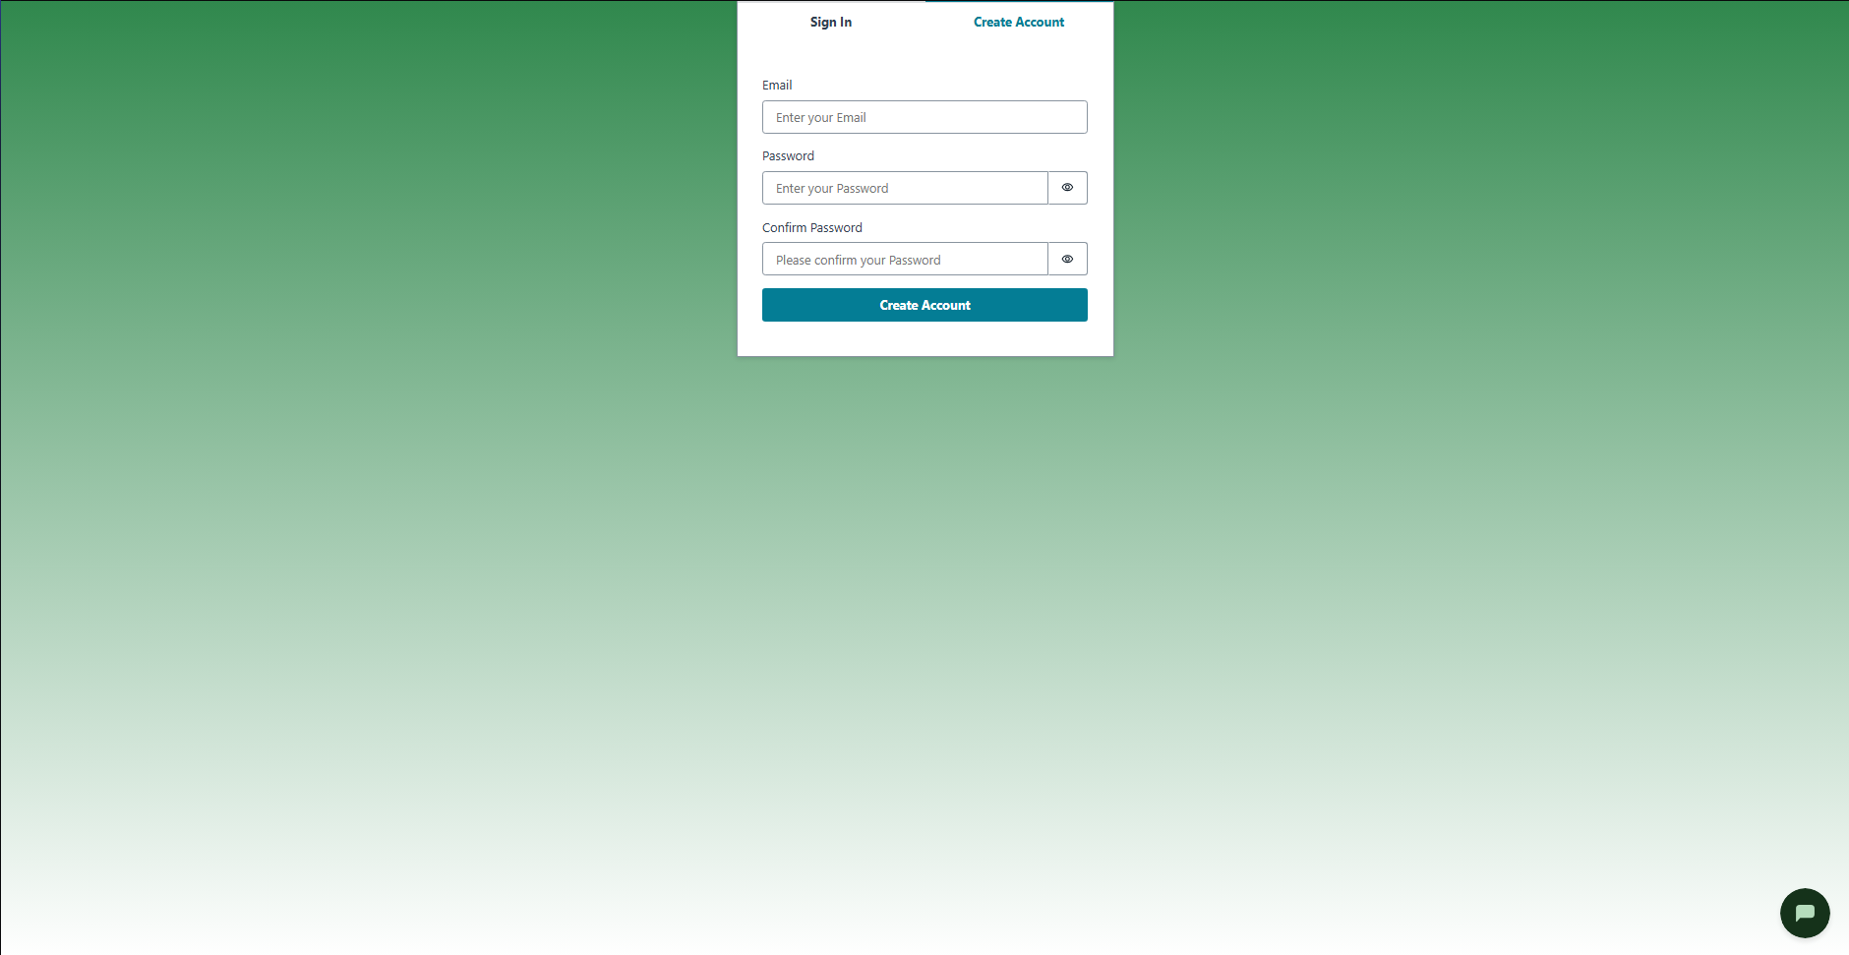
  - Select the “Create Account” tab. The prompt box below will allow you to enter your account info.
  - Select the field under “Email”.
  - Enter a valid email address for the account.
  - Select the field under “Password”.
  - Enter the password you wish to enroll into the account with.
  - Select the field under “Confirm Password”. Enter the same password that was previously entered (Step d).
  - To view the password that was entered, you can click the eye icon on the right side of the field. Clicking again will hide the password.
  - Click on the “Create Account” Button. You will be redirected to a new screen.
  - You will receive a confirmation code in your personal email. Please navigate to your email inbox and provide the confirmation code in the field. If code needs to be resent, click on “Resend Code”.
  - Once code is in the field, click on “Confirm”.
Congratulations, you have successfully created an account for 8020Fit and will have access to the homepage.

- Login to Your Account
If you’re not already signed into your account, you will have login with your credentials.
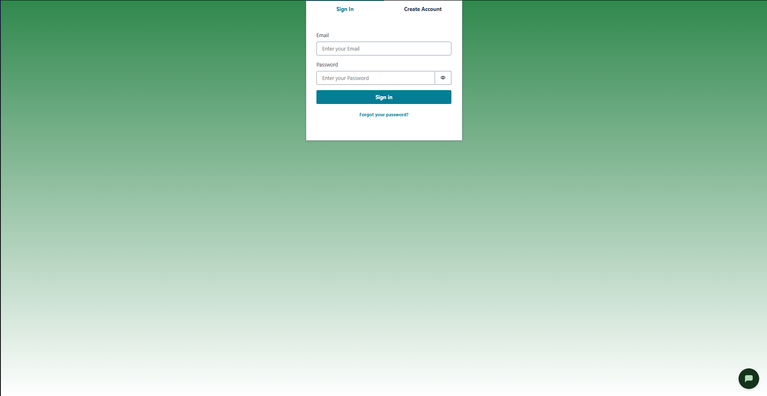
  - Select the “Sign In” tab. The prompt box below will allow you to enter your account info.
  - Select the field under “Email”.
  - Enter a valid email address for the account that is registered on the platform.
  - Select the field under “Password”.
  - Enter the password you enrolled into the account with. To view the password that was entered, you can click the eye icon on the right side of the field. Clicking again will hide the password.
  - Click on the “Sign In” Button. You will be redirected to the homepage of the webapp.

Navigation
Once you have successfully logged into your personal account, you will be brought to the Dashboard page of the fitness page. The proceeding steps will illustrate what is displayed and the components of the fitness app.

- Dashboard
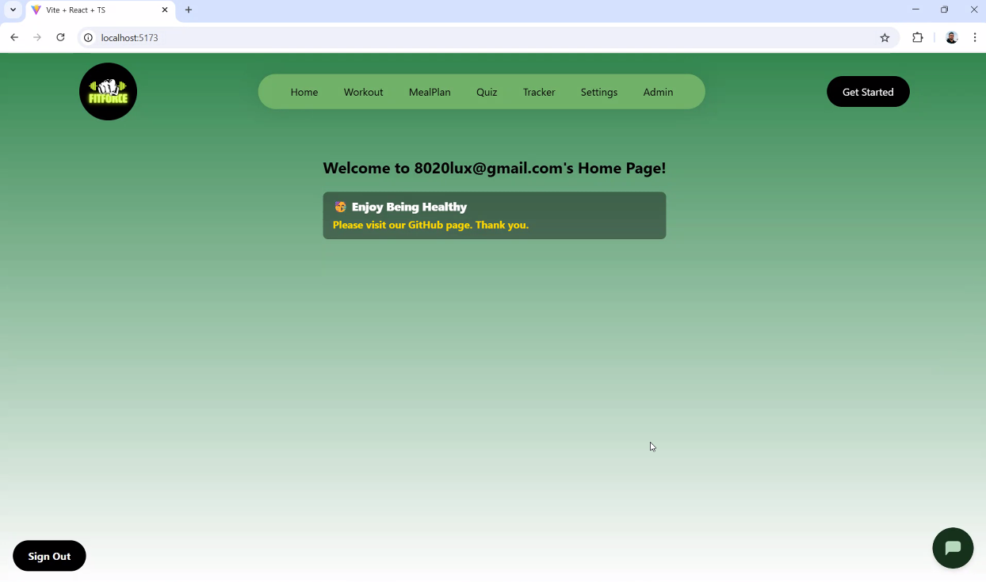
This screen displays the Dashboard page, the main page reached when a fitness user signs in.
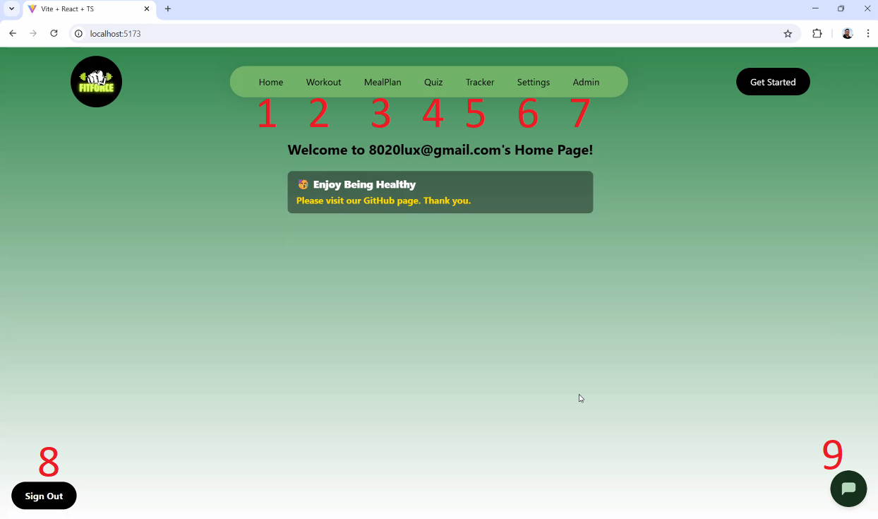
  - Home: The Home button acts as a way for users to navigate back to the main page of the dashboard. The home page is the landing page where other buttons, features, and functionalities are located.
  - Workout: The Workout section provides access to recommended exercise routines. These routines are tailored based on user preferences and goals. Each workout includes a name, category (e.g., strength, cardio), duration, required equipment, and visual demonstrations. Users can start or complete workouts and track progress in real time.
  - MealPlan: This tab features personalized meal plans aligned with the user's dietary preferences and fitness objectives. Each meal entry includes nutritional information (e.g., calories, macros), recipe instructions, and the option to swap for favorite meals.
  - Quiz: The Quiz page allows users to complete the onboarding quiz which customizes each workout plan. Quiz includes questions about goals, fitness level, dietary habits, or preferences. Results from the quiz influence AI-driven recommendations across workouts and meal plans. Users can retake the quiz at any time to update their profile settings.
  - Tracker: The Tracker section records user activity over time. Users can log completed workouts, and routines completed. Visual aids for workouts can be found housed under this tab.
  - Settings: Within the Settings panel, users can manage their account and preferences. Options include updating profile information (such as weight, age, and goals), changing password, enabling notifications, and customizing app themes or privacy settings. This section also provides access to support resources and app version details.
  - Admin: Accessible to authorized users only, the Admin dashboard enables management of platform content and users. Admins can review account privileges, review logs, and manage user access.
  - Sign Out: The sign out button allows users to log off the web app.
  - AI Chat Bubble: The icon opens up a dialogue window for users to enter prompts regarding their fitness inquiries. The AI chatbot will respond with the corresponding request.

Profile
Once you have successfully logged into your personal account, you will be brought to the Dashboard page of the fitness page. The proceeding steps will illustrate what is displayed and the components of the fitness app.

- View Profile
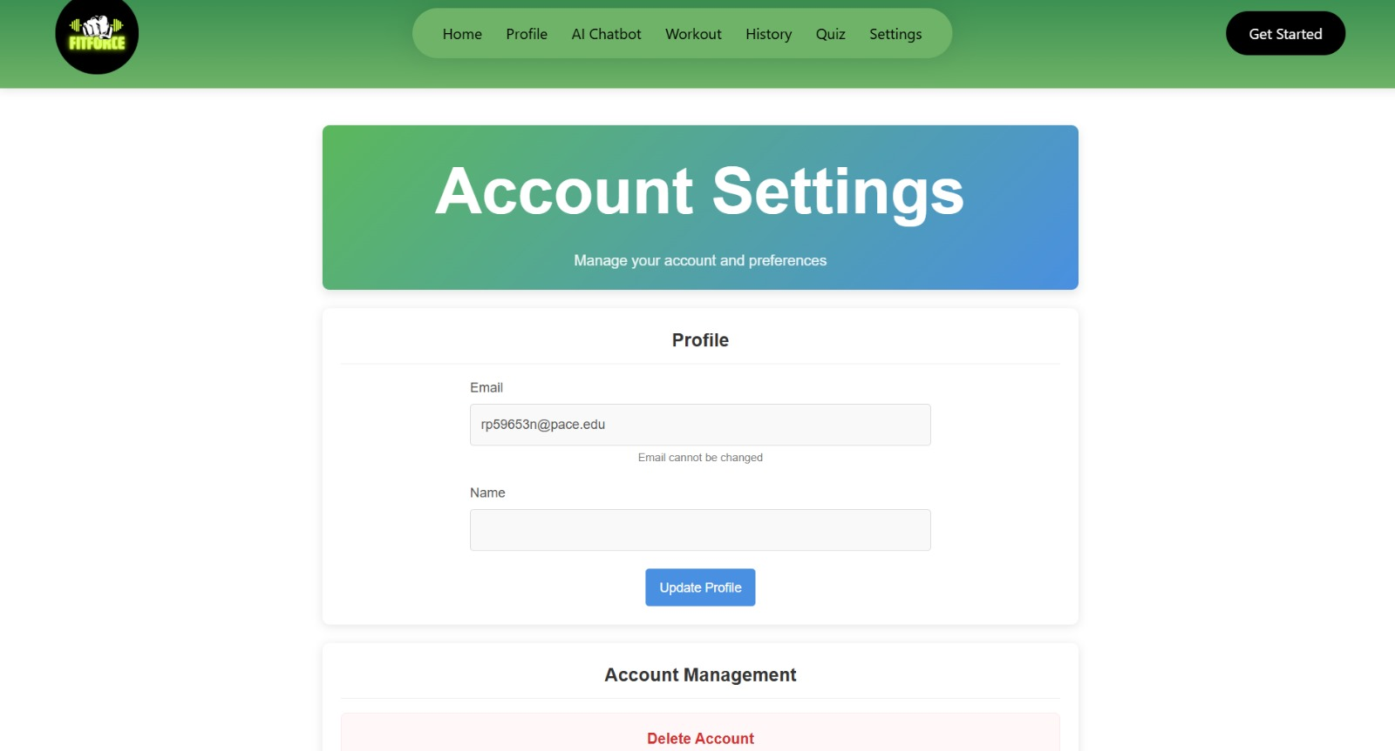
  - Select the “Settings” button located on the navigation bar at the top of the page.
  - Once selected, you will be directed to the Account Settings page. Once here you can access your profile, make changes to account details, and delete your account.
- Update Profile

  - Select the “Settings” button located on the navigation bar at the top of the page.
  - Once selected, you will be directed to the Account Settings page.
  - To update your profile information, enter corresponding changes to “Email” and “Name” fields.
  - Once completed, select “Update Profile” button. You will have successfully updated the info.
- Delete Account Profile
If you need to remove your account or personal information from our platform, here is how to do so.
  - Select the “Settings” button located on the navigation bar at the top of the page.
  - Once selected, you will be directed to the Account Settings page.
  - To delete your account and remove your personal information, scroll to Account Management on the tab.
  - Select “Delete Account” and acknowledge account deletion message.
You have successfully deleted your account.
- Logout of Account

  - Click on the “Sign Out” button at the bottom left of the page.
  - Once selected, you will be successfully signed out and be navigated to the 8020Fit login screen.
You are now logged out of your account successfully,

Workout Generation
- Take Onboarding Quiz
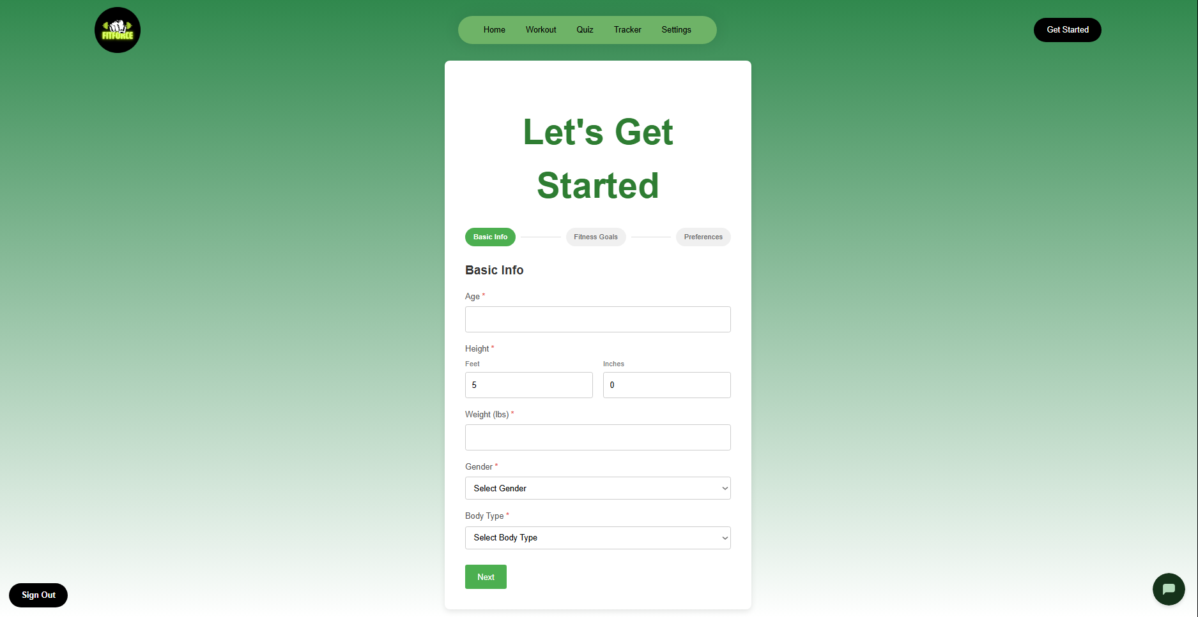
  - Click on the “Quiz” button located at the top of the screen in the navigation bar.
  - You will be redirected to the onboarding quiz to fill out info based on workout goals, fitness capabilities, and preferences.
  - Under the Basic Info form, you will enter information pertaining to your age, height, weight, gender, and body type.
  - Once completed with your information, you will click on the “Next” button. You will be redirected to the next page of the quiz.
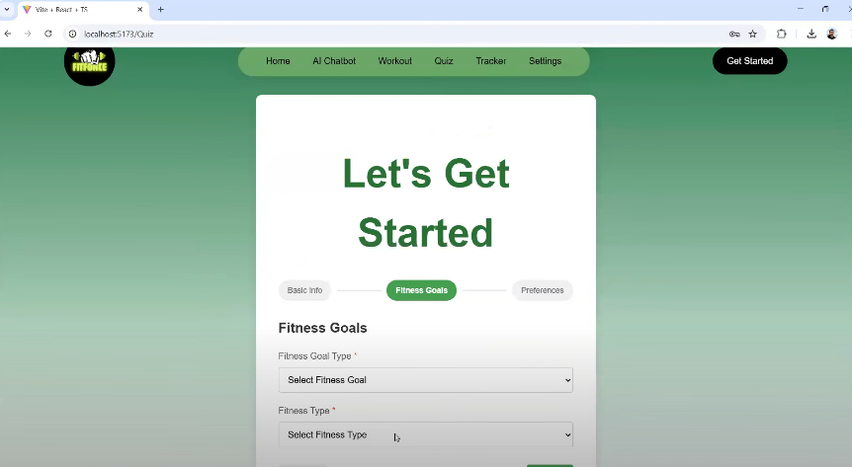
  - The Fitness Goals page will intake information on Fitness Goal type and your fitness type.
  - Click on the corresponding dropdown fields in the sections and place your information in.
  - Once completed with your information, you will click on the “Next” button. You will be redirected to the next and final page of the quiz.
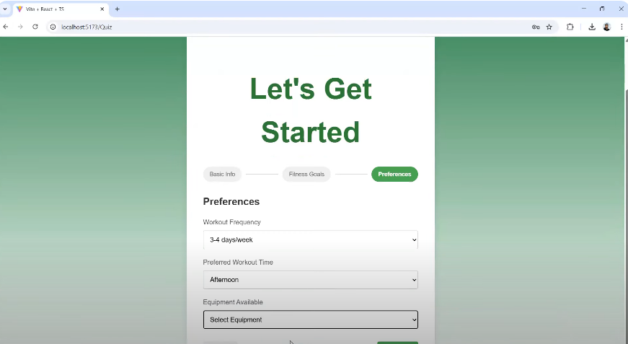
  - The Preferences page will intake information on workout frequency, preferred workout time, and available equipment.
  - Click on the corresponding dropdown fields in the sections and place your information in.
  - Once completed with your information, you will click on the “Submit” button. You will be redirected to the recommended workout page.
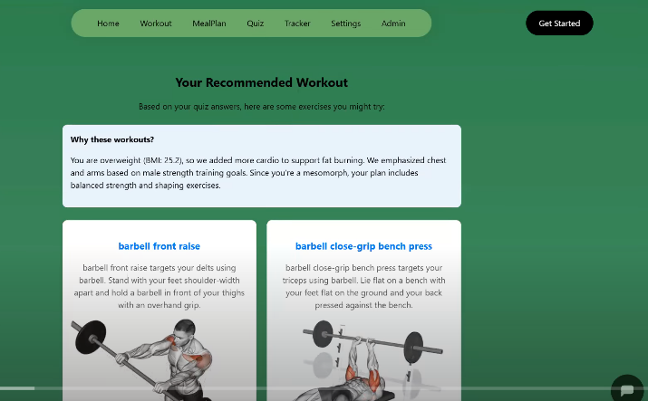
  - Once the quiz processes the information from the quiz, it generates a suggested workout routine that will help receive your fitness goals.
You have successfully completed the quiz and received a workout generation.

- View and Track Workouts
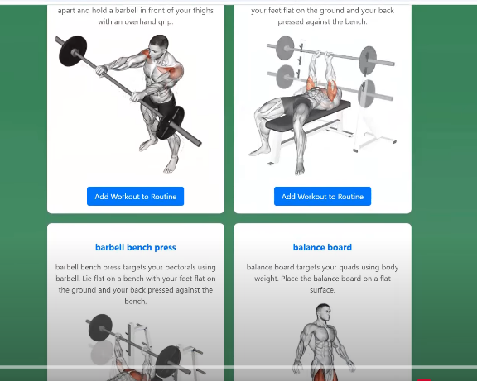
  - Workouts can be viewed from the Workout page and followed on the “Workout” or “Tracker” tab at the top in the nav bar. Explanation as to why the generated workouts were designated to you is explained first. Visualizations on how to perform routine alongside explanation of exercise will be shown.
  - To view tracked workouts, click on “Tracker” button at the top of the screen.
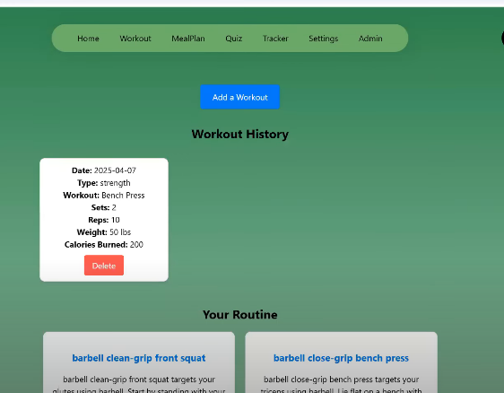
  - Click on “Add to Workout” button at the top of the page to manually enter a workout you performed. Historical record of workout will be shown below in “Workout History”.
  - Select type of Workout either Cardio or Strength.
  - Fill out fields with information about workout, sets, reps, weight, calories burned, and date. Once complete, press the “Submit” button.
  - To remove a workout, click on “Remove from Routine” button.

Meal Plan
- Enter Meal Preferences
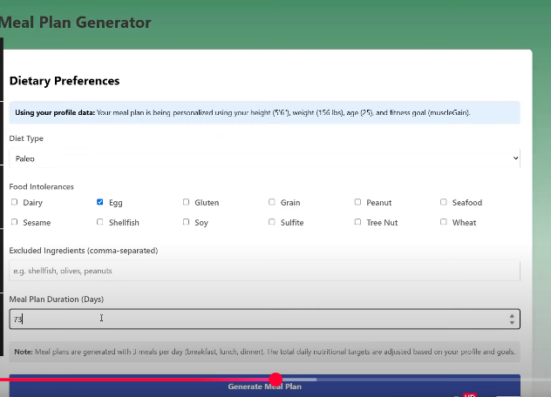
  - Click on the “MealPlan” button located at the top of the screen in the navigation bar. You will be redirected to the meal plan form page.
  - You will then be able to fill out the dietary preferences based on diet type, food intolerances, foods that need to be excluded, and duration of meal plan.
  - Under “Diet Type” field, you can select options from the dropdown.
  - Under “Food Intolerances” field, you can mark options from the provided list.
  - Under “Excluded Ingredients” field, you can fill in the field with corresponding info.
  - Under “Meal Plan Duration” field, you can select options from the dropdown.
  - Once completed, you can press on the “Generate Meal Plan” button. You will be redirected to the final meal plan page.
- View Meal Plan
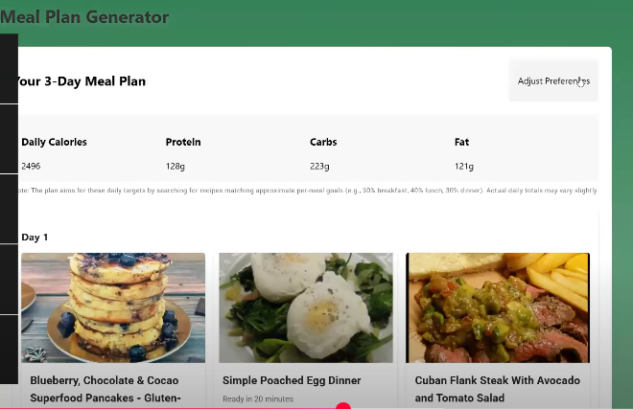
  - Once you have accessed the meal plan page, you can view additional options. You will have access to recipes, multiple days of food, and caloric information.
  - Clicking on the “View Recipe” button will populate complete recipe of the meal. Source websites can be clicked on for more information.
  - Daily macronutrient data can be found on the top of the top page.

AI Chatbot
- AI Chat Prompts
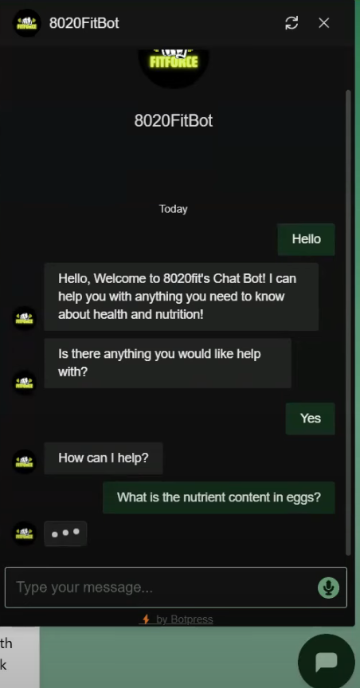
  - Click on the chat button located at the bottom right corner of the screen in the navigation bar. The chat button can be accessed at any time at the bottom of any page.
  - Once chat bubble is open, type “Hello” into the text field. You will see the chat bot typing a message back to you and respond.
  - You may then proceed to ask it any questions you need assistance with.

Admin
- View Admin Features
This view is limited to admin with the specific permissions to this page.
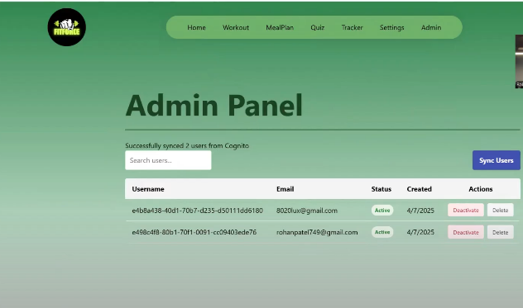
  - Click on the “Admin” button located at the top of the screen in the navigation bar. You will be redirected to the admin form page.
  - Admin can sync users, search for, deactivate, or delete accounts.

Contact Information
We appreciate any feedback on our project. Please feel free to share any thoughts, concerns, or issues. For further information or assistance, please reach out to:
- Contact Email: fitforce@gmail.com
- GitHub Repository: https://github.com/htmw/2025SA-Team2.git

